1. Classes

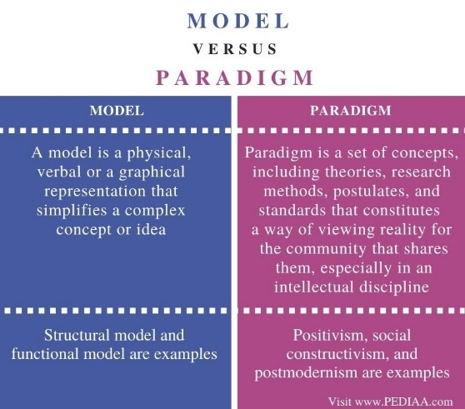

Object-oriented programming is a paradigm of programming languages that groups data and the code that manipulates it, together into logical units called object

Class is a template to make objects

Constructor :xác định cách tạo ra đối tượng của class

Đoạn code này chạy khi một object được tạo ra để khởi tạo object đó

Constructor không trả về type và tên giống với class

Instance variable của một object

Method is a procedure or function in object-oriented programming

Function is a group of reusable code that can be called anywhere

1. New

Classes are types so we can use class types to declare variables

Heap: data does not go away when a function returns destroying its frame

1. Methods

1. Types

A Type specifies how data should be represented, interpreted (diễn giải), operated on(vận hành), cũng như những thao tác bạn có thể thực hiện với dữ liệu đó

* Types: interpretation + operation

1. For Each Loops

